CAS COLOMBO AMERICAN SCHOOL
“Educating Transformative Leaders”
STEM 2020

SUBJECT: | STEM | LEVEL: | 7th | TERM: | I

COURSE:

TEAM MEMBERS:

PROBLEM | According to the challenge chosen by the group, make the electronic circuit, explain real application of that circuit and explain math concepts applied into it.
GOAL | To make an electronic circuit using Arduino and components..
TOPICS | Programming  IF-ELSE  VARIABLES  Physics  Math
INSTRUCTIONS:
Join a team, choose the role and start the process of the scratch program.
Ask, imagine and plan.
Create, test and improve.

Roles

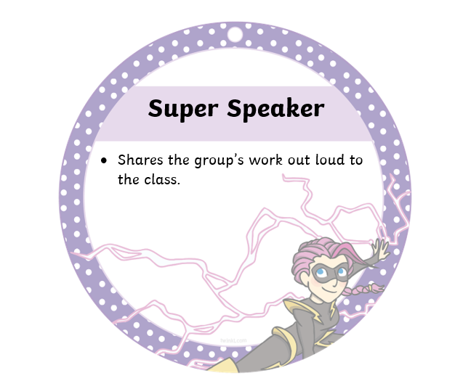  Name: | 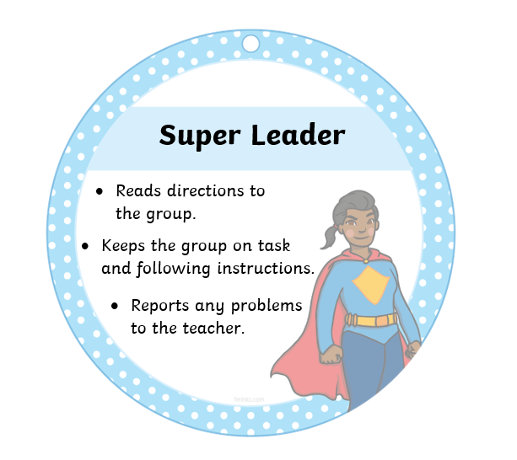  Name:
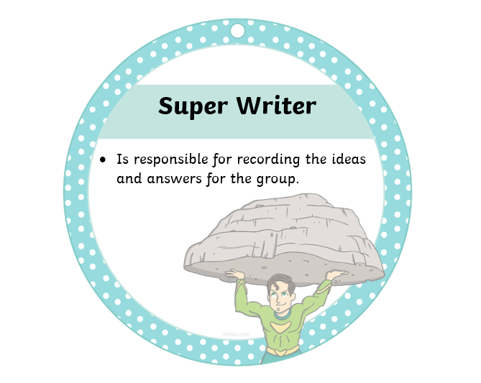  Name | 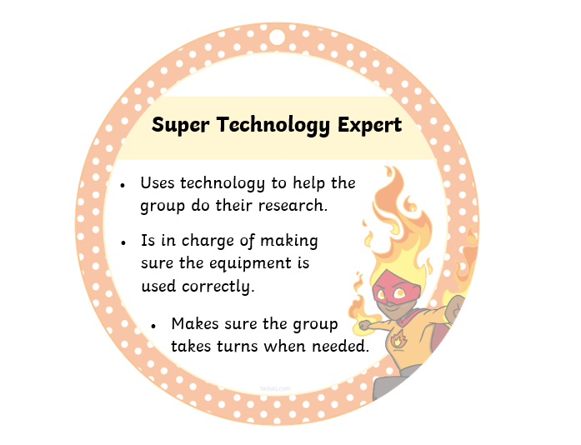  Name:

Scratch Program Photosynthesis

Reflect and Share

After testing your design, it is important to reflect on  whether or not your design worked.  What would you change with your design and why? | Compare your design to a partner’s. How is your design the same, and how is it different?

Script for the video

Take into account

- Explain what is the challenge about.
- Explain the problem you want to solve with that invention. How it can help people in real life situations?
- Show the process.
- Explain the math application according to the invention.
Write your script, check grammar and be creative!!!

